CS 6402 – Advanced Data Mining
Spring 2020
Exam #1

This take-home exam is due by 3 p.m. on Wednesday, February 26, 2020.

IN-CLASS students must turn in a PAPER copy of their exam in class on the due date.
DISTANCE ED students should submit a single pdf file via Canvas by the due date.

This exam is open-book. However, you may not communicate with any person about any aspect of the exam until after the due date.

If you have questions about any of the problems, contact Dr. Leopold via email (leopoldj@mst.edu).

Your answers to all problems on this exam MUST be very neat and legible, and IN THE SAME ORDER THAT THE PROBLEMS APPEAR ON THE EXAM; otherwise, they will NOT be graded!!!
You can use extra paper (besides the exam paper), but you must assemble the answers you submit IN THE SAME ORDER as the problems are given in the exam!

NOTE: There is a better chance that you will get partial credit for an incorrect solution to a problem if YOU HAVE SHOWN YOUR WORK! Therefore, you should show how you arrived at your solutions, regardless of whether the problems explicitly ask you to do so!!!

Good luck!!!

P.S. For lexicographic/alphabetizing/canonical purposes, digits (0-9) come before uppercase letters (A-Z); uppercase letters come before lowercase letters (a-z).
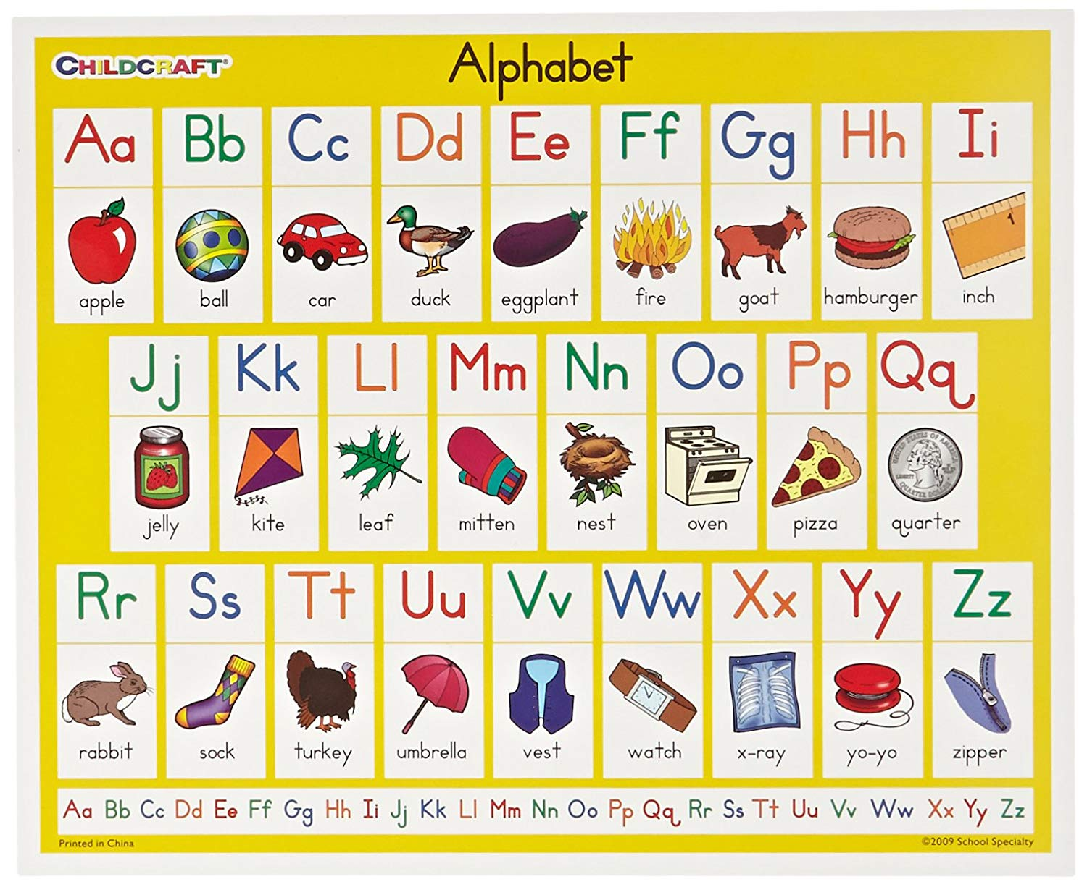
- Consider the following graph:
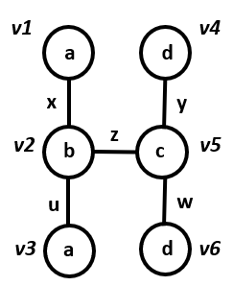
Using the vertex invariants scheme, construct the (minimal) canonical label for this graph. SHOW YOUR WORK in the application of this method; otherwise you will receive NO CREDIT for this problem. (6.5 pts.)
Hint: You will need to consider different permutations of the partitioned matrix!

- Consider the following graph:
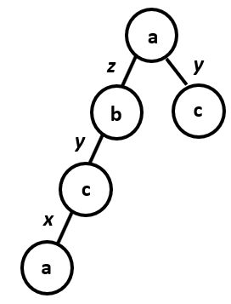
Using the minimum depth-first search code (M-DFSC) strategy, find the minimal canonical label for this graph. Show EVERY POSSIBLE M-DFSC encoding for this graph so that we can see that your choice of a canonical label is the minimal M-DFSC. (6.5 pts.)

- Consider the following graph:
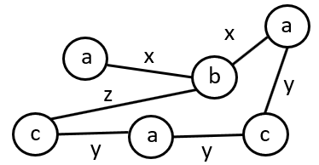
Shown below is the start of (what is intended to be) a DAG of canonical adjacency matrices for connected subgraphs of this graph. Using extension and join operations, construct ONLY ONE more level in the tree off of S1, S2, and S3 (i.e., only create child nodes for the nodes labeled S1, S2, and S3); you are NOT being asked to construct the entire DAG for the graph! CLEARLY EXPLAIN the join and extension operations you are doing for each node. You must give the canonical adjacency matrix (as calculated including diagonal entries) AND draw each subgraph node in your solution! (4.5 pts.)

WHEN YOU’RE FINISHED, RE-DRAW THE TREE SHOWING THE CHILDREN OF S1, S2, AND S3, WITH THEIR MATRICES AND PICTURES OF THEIR GRAPHS!

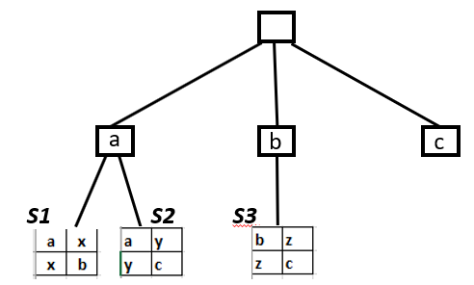

- Consider the following collection of 3 graphs:
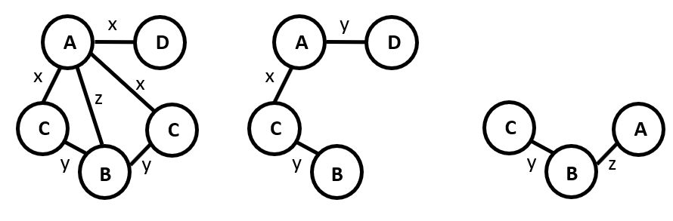
Show how gSpan would find all frequent subgraphs using a minumum support threshold of 2. At the conclusion of your work, DRAW all of the frequent subgraphs you found. SHOW ALL OF YOUR WORK IN DOING THE ALGORITHM! (10 pts.)

- In class we discussed two different methods for determining which subgraph to choose for compression in the SUBDUE algorithm: Minimum Description Length (MDL) and Size. In the graph given below, use the Size method to determine whether the subgraph containing vertices {A, B} or the subgraph containing {C, D, E} would be chosen for the very first compression of the graph G. SHOW YOUR WORK in how the determination is made and SHOW EACH OF THE TWO POSSIBLE COMPRESSED GRAPHS! (4.5 pts.)
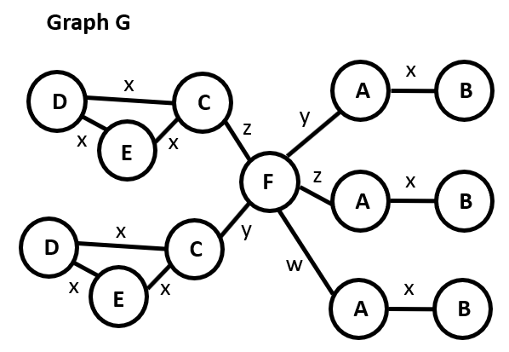
Note: The formula for the Size method is
value(S, G) = VE_size(G) / (VE_size (S) + VE_size(G|S))
where VE_size(G) = # vertices(G) + # edges(G)

- Consider the following graph:
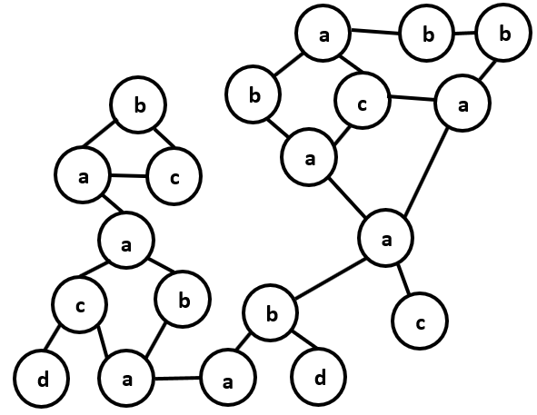
Suppose that HSIGRAM is considering the frequency of the subgraph shown below:
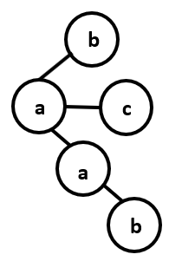
Construct an embedding overlap graph for this subgraph. Then compute the size of the overlap graph. SHOW HOW YOU ARRIVED AT YOUR ANSWER (i.e., show the computation of the MIS for each embedding that must be considered in the overlap graph). USE A DIFFERENT COLOR TO DRAW EACH EMBEDDING; go buy a small package of crayons or something 😊 (7.5 pts.)

- Consider the graph shown below:
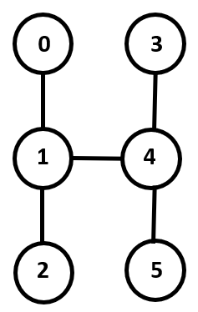
- What would be the equitable refinement of the unit partition, R(µ), according to the Nauty algorithm? CLEARLY EXPLAIN HOW YOU GOT YOUR ANSWER! (1 pt.)

- The Nauty algorithm generates a “search tree” with a root that is the equitable refinement of the unit partition, R(µ) (i.e., your answer to part a). Show what the leftmost child (partition) would be off of the root node of that tree. CLEARLY EXPLAIN HOW YOU GOT YOUR ANSWER! (4 pts.)
Note: You do NOT have to generate the entire search tree; this question is only asking for one node of the tree!

- In class we discussed that when you execute the autgrp function in Nauty (for example in Python), one of the outputs you get is what it calls generators. Give one set that would qualify as a single generator set for the graph given in this problem. (1 pt.)

- West Nile virus is an infectious disease that first appeared in the U.S. in 1999. Mosquitoes contract the virus when they bite birds infected with the disease. Birds can become infected with the virus through mosquito bites. Some predatory birds (like hawks and owls) can also contract the virus from eating other dead birds. Most birds that contract the virus will live, but some birds (like jays and crows) often die. Mosquitoes transmit the virus to humans, dogs, and horses when the mosquitoes bite them; female mosquitoes are the biters because they need a blood meal to help them produce their eggs.
Suppose that a team of scientists has compiled a dataset of the locations of individual humans, dogs, horses, mosquitoes, and birds that contracted the West Nile virus over a period of time. Based on DNA, the scientists also know which individual (directly) transmitted the virus to which other individual. (Here an ‘individual’ could be a mosquito, bird, human, horse, or dog.)
Briefly explain how frequent subgraph mining (FSM) could be used to meaningfully study this dataset. Pose at least one interesting (“scientific”) question that could be addressed by a FSM analysis. Your solution must include a brief description of what the graph would look like (i.e., what the vertices and edge would represent). (4.5 pts.)


